**Homework 4**

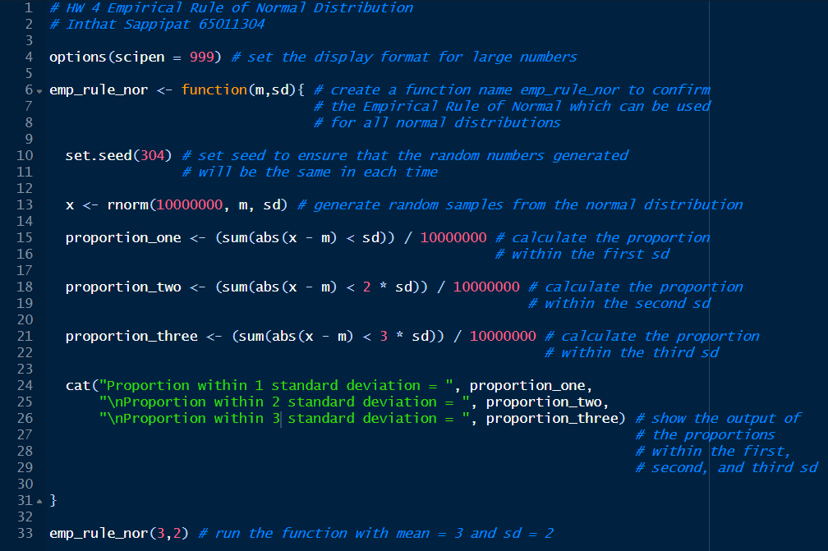**Code:**

**Result:**

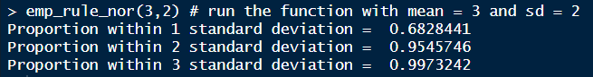

**Conclusion:**

From the experiment, the proportion within 1 standard deviation is equal to 0.6828441 or 68.28 %, the proportion within 2 standard deviation is equal to 0.9545746 or 95.45 %, and the proportion within 1 standard deviation is equal to 0.9973242 or 99.73 %. Comparing these three proportions with the theoretical probabilities of 0.68, 0.95, and 0.997, I found that they are quite close. This confirms that the given normal distribution with mean and standard deviation is consistent with the Empirical Rule.